**How to Setup the backend**

*Let consume domain name **xyz** (https://xyz.com)

**Follow these simple steps to setup your backend**

1. Download the zip files, extract them, go to folder name: “**backend_codes and doc**” & find “**public_html.zip**”
2. Upload the zip files on your server, un-zips the folder under the *public_html*

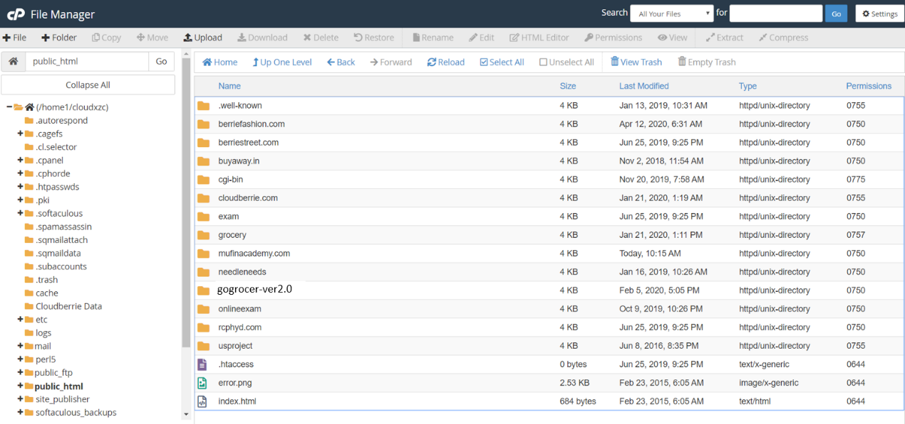

1. **Hit the url into the browser https://xyz.com/ gogrocer-ver2.0 you can get the activator page**

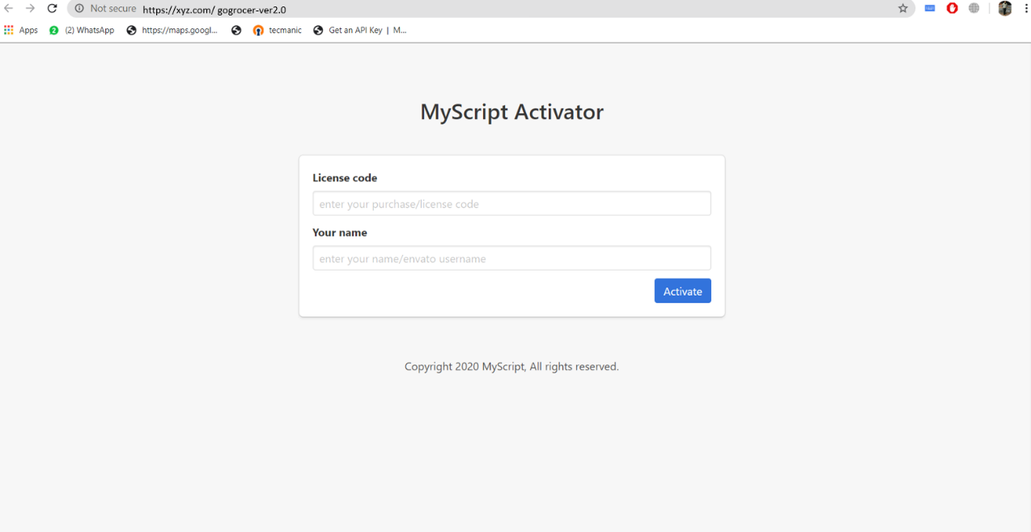

1. **Create a new database ( copy the database name & password)**

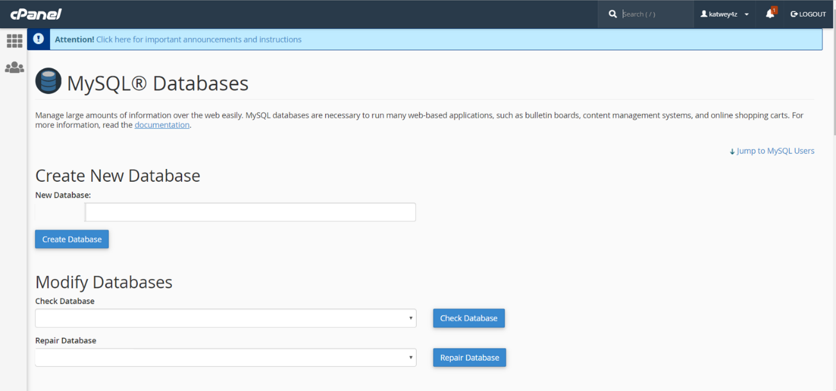

1. **After successfully creating the database, go to the browser open the same url https://xyz.com/ gogrocer-ver2.0**
2. Use the license code & Name which you get in the invoice

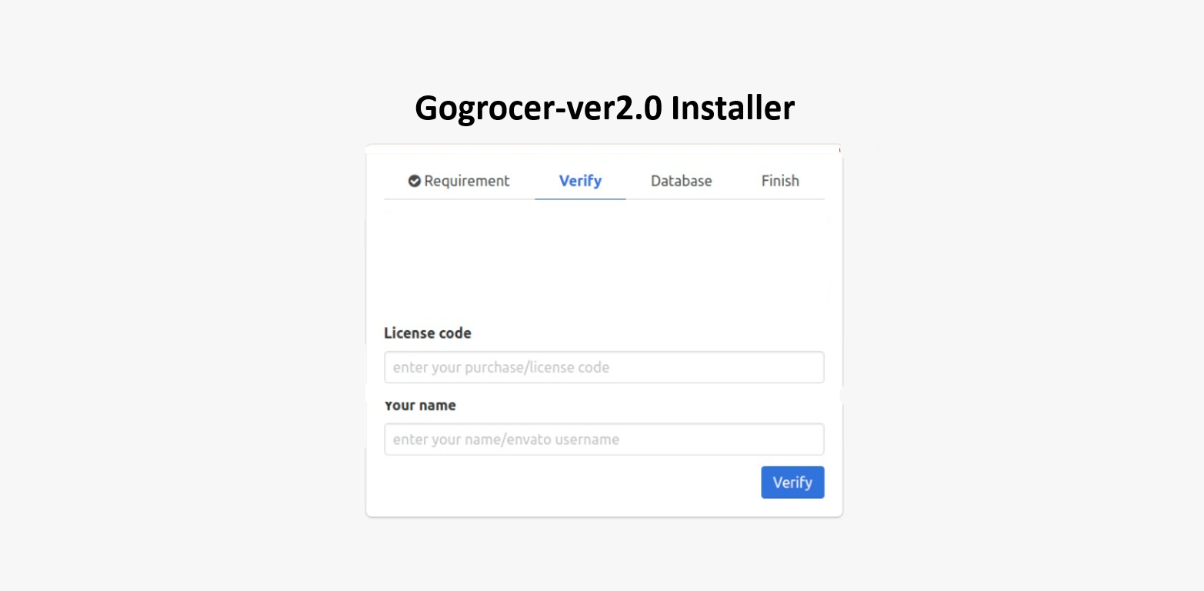

1. After verifying the license code, use database credentials which you have copied earlier

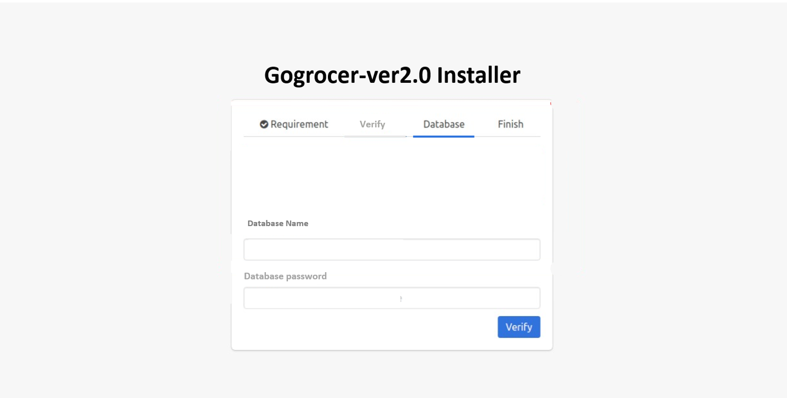

After submitting all the details you have saw this page

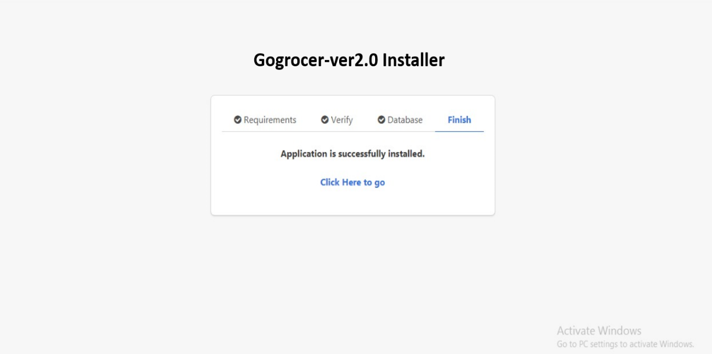

After click on click here to go , now you are ready to use the backend, you can can saw the admin Panel login page

**Credential:   
E-mail:** [support@tecmanic.com](mailto:support@tecmanic.com)  
**password:** tecmanic

Use these credentials to login

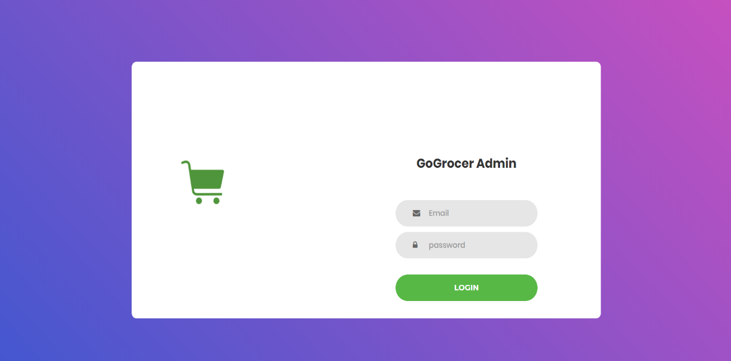

After successfully login here the home page   
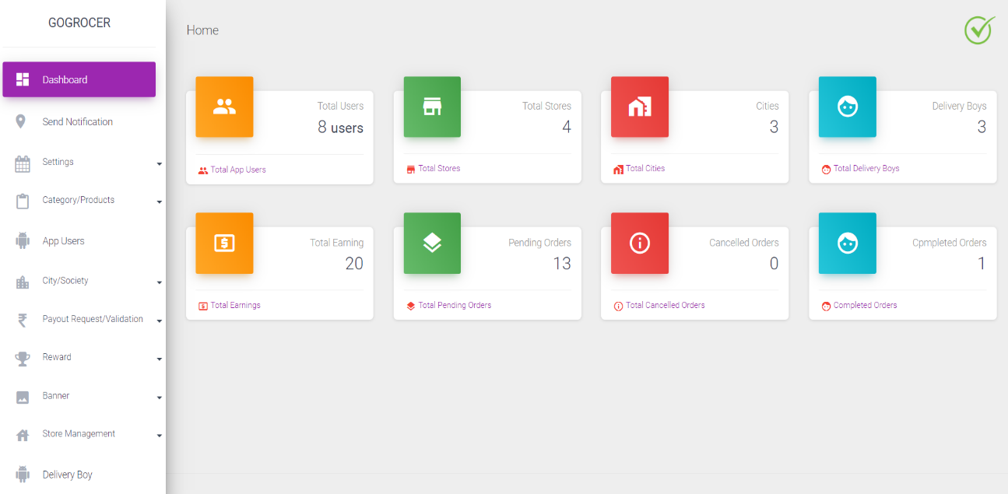

6. **Google map API creation**  
create a google map api key from Google console account and place it in admin panel ***Settings->Google Map API*** .

When your Google Maps Api key works successfully, the problem with Add delivery boy, Add store and Add area section will be solved. You have to create google map api key by your own via below link- <https://console.cloud.google.com/google/maps-apis/overview>

**Note-** Add card in Billing section is mandatory when you create google map api key. Check your google map api key with this link.

[https://maps.googleapis.com/maps/api/geocode/json?latlng=-27.0000,133.0000&key=***Place***](https://maps.googleapis.com/maps/api/geocode/json?latlng=-27.0000,133.0000&key=Place) ***your google map api key here***

see the attached screenshot i you will get response like that it means your map api key is working.otherwise your map api key is not working.

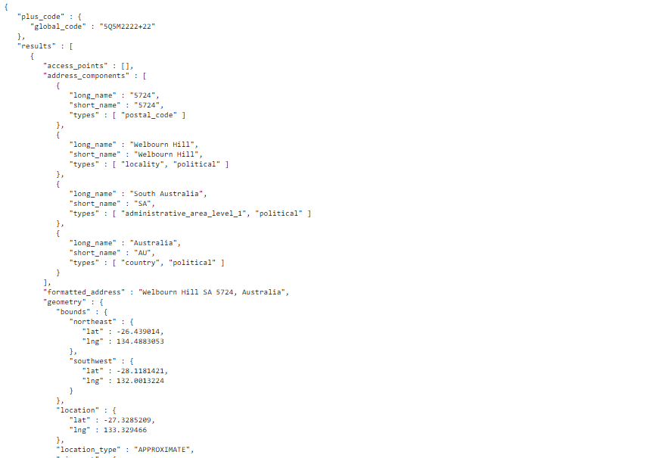

7.**FCM Server Key Creation-  
For Sending Notification to user app , store app and driver app-**

[**https://documentation.onesignal.com/docs/generate-a-google-server-api-key**](https://documentation.onesignal.com/docs/generate-a-google-server-api-key)

**Sir follow the steps from above doc to create server key for all apps and place it on Admin panel *Settings->FCM***

***User App FCM Server Key* = for customer app,**

***Store App FCM Server Key* = For store app**

***Driver App FCM Server Key* = For Driver app**

**8. Choose a Message gateway  
choose a message gateway via *settings->sms/OTP settings.***you can choose between two message gateways msg91 or twilio .  
  
**NOTE-** if you choose msg91 then you have to buy transaction sms package of msg91.  
 **If you don’t want to use any message gateways for the project then you simply choose OTP/Message Off from dropdown in *settings->sms/OTP settings.*9.Setup SMTP details**  
**sir you have to setup your SMTP from source/.env**

MAIL_DRIVER=smtp

MAIL_HOST=smtp.gmail.com

MAIL_PORT=465

MAIL_USERNAME=smtp mail

MAIL_PASSWORD= smtp password

MAIL_ENCRYPTION=ssl

***------------------------------------------------------------------------------------------------------  
 Now your backend is ready to go live.***

***-----------------------------------------------------------------------------------------------------***